SIMATS ENGINEERING
ASSESSMENT TOOL 3 - Output Prediction
COURSE NAME: Data Structures COURSE CODE: CSA0308
Register Number | 192521477
Name | Santhosh S
Assessment Tool Weightage: 35%
COURSE OUTCOME COVERED
CO1: Apply suitable data structures and ADTs for efficient problem solving by analyzing time and space complexity. (BL3, BL4)
Questions: 5 EACH QUESTIONS CARRIES: 5 MARKS Total Marks: 25 Duration: ONE HOUR
S. No. |  | List of Questions
1 | Array Traversal Program | 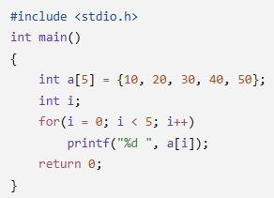
2 | Sum of Array Elements Program | 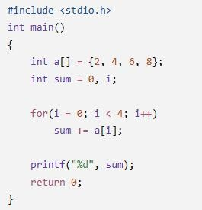
3 | 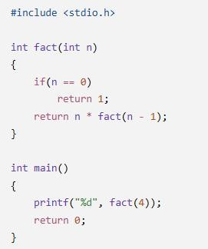  Recursive Factorial Program
4 | 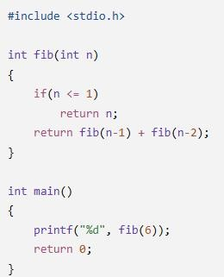  Recursive Fibonacci Program
5 | 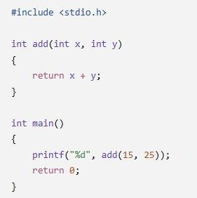  Function as ADT Operation Program
Code of Conduct:
I Santhosh S/ 192521477 certify that this submission is my original work and that I have adhered to the guidelines specified for this assessment.
I understand that any violation of academic integrity rules will result in disciplinary action.
Sanjay J
Signature of the student:
RUBRICS FOR CALCULATION:
Criteria | Weightage (5 Marks) | Level 4 – Exemplary  (5 Marks) | Level 3 –  Proficient  (4 Marks) | Level 2 – Developing  (3 Marks) | Level 1 – Beginning  (1–2 Marks)
Understanding of Program Logic | 1 | Correctly identifies the complete program flow and  execution sequence. | Minor misunderstanding of program flow. | Partial  understanding of logic. | Unable to interpret the program logic.
Trace of  Variables /  Function Calls | 1 | Accurately traces all variable values, iterations, and recursive calls. | Traces most values correctly with minor errors. | Traces some values but misses important steps. | Incorrect or no tracing.
Output Prediction Accuracy | 2 | Output predicted completely and correctly. | Output mostly correct with minor mistakes. | Output partially correct. | Output incorrect or missing.
Complexity  Interpretation  (Time/Space) | 1 | Correctly identifies and justifies complexity where applicable. | Correct complexity with limited justification. | Partial  understanding of complexity. | Incorrect or no complexity analysis.

Array Traversal Program
Concept: Traversal means visiting and displaying each array element.
Program:
#include <stdio.h>
int main() {
int arr[5] = {10, 20, 30, 40, 50};
int i;
for (i = 0; i < 5; i++) { printf("%d ", arr[i]);
} return 0;
}
Output:
Array elements are:
10 20 30 40 50
Complexity: Time O(n), Space O(1) auxiliary.

Sum of Array Elements Program
Concept: Add all array elements using a loop and a variable named sum.
Program:
#include <stdio.h>
int main() {
int arr[5] = {10, 20, 30, 40, 50}; int i, sum = 0;
for (i = 0; i < 5; i++) {
sum += arr[i]; }
printf("Sum = %d", sum);
return 0;
}
Output
Sum = 150
Complexity: Time O(n), Space O(1) auxiliary.

3.Recursive Factorial Program
Concept: Recursion occurs when a function calls itself. The factorial of nn is n×(n−1)!n×(n−1)!, with 0!=10!=1.
Program:
#include <stdio.h>
int factorial(int n) {
if (n == 0 || n == 1) { return 1; }
return n * factorial(n - 1);
}
int main() {
int num = 5;
printf("Factorial = %d", factorial(num));
return 0;
} Output:
Factorial = 120
Complexity: Time O(n), Space O(n) due to recursive calls.

Recursive Fibonacci Program
Concept: Each Fibonacci number is the sum of the previous two numbers. The sequence starts with 0 and 1.
Program:
#include <stdio.h>
int fibonacci(int n) {
if (n == 0) { return 0; }
if (n == 1) { return 1; }
return fibonacci(n - 1) + fibonacci(n - 2); }
int main() {
int i, n = 7;
for (i = 0; i < n; i++) {
printf("%d ", fibonacci(i));
}
return 0;
}
Output :
0 1 1 2 3 5 8
Complexity: Time approximately O(2n), Space O(n).

Function as ADT Operation Program — Stack
Concept: A Stack ADT follows LIFO (Last In, First Out). The last inserted element is removed first.
The operations are push, pop, and display.
Program:
#include <stdio.h>
#define MAX 5
int stack[MAX]; int top = -1;
void push(int value) {
if (top == MAX - 1) {
printf("Stack is full\n");
} else { stack[++top] = value;
printf("%d inserted into stack\n", value); }
}
void pop() {
if (top == -1) { printf("Stack is empty\n");
} else { printf("%d removed from stack\n", stack[top--]); }
}
void display() { int i;
if (top == -1) {
printf("Stack is empty\n");
} else { printf("Stack elements: ");
for (i = top; i >= 0; i--) {
printf("%d ", stack[i]);
}
printf("\n");
}
}
int main() { push(10); push(20); push(30);
display(); pop(); display();
return 0;
} Output:
10 inserted into stack
20 inserted into stack
30 inserted into stack
Stack elements: 30 20 10
30 removed from stack Stack elements: 20 10
Complexity: • Push: O(1)
- Pop: O(1)
- Display: O(n)
- Stack storage: O(n)

